
ICE: THE CAMEL FACTOR TRIBUTE
v1..0
technical Rider Ice
ICE: THE CAMEL FACTOR TRIBUTE
Inhoudsopgave

General 2
INFO | REQUIREMENTS 2
Line up 3
Technical requirements 4
Amplification Drumkit 4
BACKLINE 4
Connection to FOH 5
Channel overview: 6
FOH 6
Sound engineer 6
Stage 7
Monitoring 7
Backup IEM possibility. 7
Video 7
Power supply 8
Stageplan Ice 9
9
9
9
Appendix 10
Connection diagram 10
Patchlist 11

General
This rider is based on an example formation and the most ideal situation. If in reality the resources are not available to meet the demands of us as a band, please let us know in time. We can find a suitable solution for this in consultation.

INFO | REQUIREMENTS
Ice assumes a stage of at least 6 x 4 meters with a drum riser of 2 x 3 meters and a keyplayer riser of 2 x 3 meters. And set-up may change for other stage sizes. Please consult in advance, if this is the case. The stage should be easily accessible for technology and musicians
- ICE assumes that there is a lockable dressing room for the band.
- ICE assumes that the band and accompanying technicians will be provided with (soft) drinks and bottles of water on stage. (max 7 persons)
- ICE expects a hot meal when setting up or playing around dinner time.
- ICE reserves the right to invite people for a short-term viewing during a performance (always in consultation).
- ICE plays according to the agreed time. Extra time is possible in consultation at an additional cost
- ICE name and date of the performance. Payments for performances arranged through the booking office are made through the booking office.
- ICE or the booking office will provide wage statements on request.
- ICE only works with professional sound companies and equipment. In the case of PA not provided by the organizers themselves, the organizer must contact the sound company well before the performance.

Line up

Band member | Instrument
Alex Geerts | Bas + vocals
Hans Velders | Guitar + Vocals
Cornel Leydekkers | Keys (2x)
Ronald Peet | Drums
Francois Teering | Vocals, Keys
Rien Broekhuijsen | Wind Instruments, vocals

Technical requirements

ICE has its own In Ear Monitoring system (Behringer X32 Rack) SO we are self supported on stage except for 2 active monitors we need.

BACKLINE
ICE will bring its own backline, consisting of:
- Drumkit
The drumkit is amplified by the venue, a drums return line (stereo) is profided to the SD8 of Ice to compliment their in-ear monitors with drums.
  - Basedrum, 2x snare, hihat, 3x toms, 2x floor toms, 7x cymbals
- Guitar Axe FX (no cabinets or amplifier)
  - Signal split at X32 Rack for FOH (XLR male, stereo)
- Bass amplifying (no cabinet)
  - HARTKE HA 3500 A, Signal split at X32 Rack for FOH (XLR male)
- Keyboard + Synthesizers
  - Signal split at X32 Rack for FOH (XLR male)
- Backing tracks
  - Stereo signal (2x xlr from the Ice X32)
- The lead vocal uses a Voice Live 2 to which the microphone is connected.
  - Signal split at X32 Rack for FOH (XLR male, phantom power through VoiceLive2, stereo)
- 4x Backing Vocals (Dry Land has NEEDS MICROFOONS FROM VENUE)
- 1x Flute etc.
- Ice has its own IEM systeem (In Ear Monitoring). It is a Behringer X32 + 2 x SD 8 Breakout + 2x MS 8000 XLR splitter
  - Iceuses a Backing Tracks from a laptop, which through the X32 is offered to FOH. (Signal to FOH through X32 (XLR Female, stereo)

Connection to FOH

We come with our own sound engineer Paul van Zeeland 0654637263 (for info and questions) Paul needs a centre space halfway in the hall.

We come with our own foh desk and stageblock and we like to plugin the foh system in the left and right and sub configuration. And the only thing we need is the cat 6 cable, from the regie to the stage.
As mentioned above, ICE uses its own In Ear Monitoring system (Behringer X32 rack) from which all signals, except the drumkit, are split to FOH, using 2x build in Behringer Utralink MS 8000. The signal is split before entering the IEM system. The dry signal from all instruments is thus presented to FOH through 2 multi cables, 2x SD8 stage box and 2 XLR cables for backing tracks.
All signals are offered in the following:
- 2x XLR multikabel with each 8x XLR male connector
(channels 1-8 en 9-16)
- 2x XLR female from the X32 for the backingtracks

FOH

The PA, provided by the organizer, must be of good quality and have sufficient power for the location. The audience must be provided with good and undistorted sound. In addition, it must be able to handle the above occupation. PA includes all equipment outside the instruments. PA includes:

• FOH PA (included Subs)
• Vocal Microphones + Stands
• Light installation including light engineer.
• All associated cabling
• Engineer who can build, patch and clear away the complete installation

Stage
Using the stage:
The stage must have a minimum size of 6 x 4 meters (width x depth). The drummer and the keyboardplayer requires a platform of 2 x3 meters in case of large stage.
We adapt to the situation as far as the set-up is concerned. In principle, we try to use the set-up as shown in the Stage Plan. Drums, left of center back of stage with keys to his right (seen from audience). Right in front of the stage guitar and left in front of the stage the bass guitar. Lead vocals (incl. keys and guitar) in the center front of the stage. Wind Instruments left from the center.

Video

ICE uses video images that are in sync with the music. These videos are automatically started from the laptop which is located directly next to the ICE IEM X32 Rack. Because the laptop is connected to the ICE IEM X32 Rack via USB-C, this distance cannot be increased. The client must offer an (HDMI) cable (connected to a projector) to the laptop at the location where the IEM X32 Rack is located.

The Venue will provide a videoprojector (with HDMI Input) and screen, capable of projecting video’s.The HDMI cable where Ice connects its computer for the visueal must be available at the stage.

Power supply
Within a reasonable distance of the stage there should be two free, clean groups with 16 amps 220 volts (edge grounded). Everything according to government safety regulations. Any deviation from these provisions must be reported immediately.
It is possible to deviate from the aforementioned requirements in consultation. ICE will never take decisions independently, but always in consultation with the client. This person remains responsible and contact person for matters relating to the sound system, unless this is provided by ICE itself.

Stageplan ICE
2XLR Stereo drums monitor (return from FOH to X32 Ice)

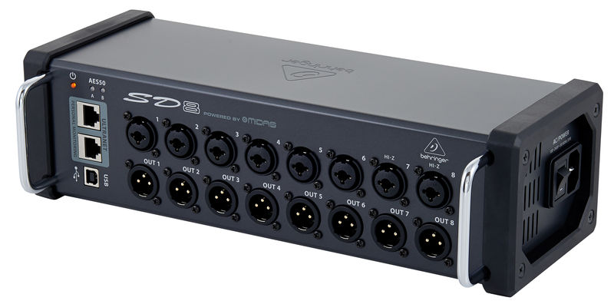

Laptop BCKNG


2x XLR backing track
FOH
8x XLR signals
8x XLR signals
X32 IEM
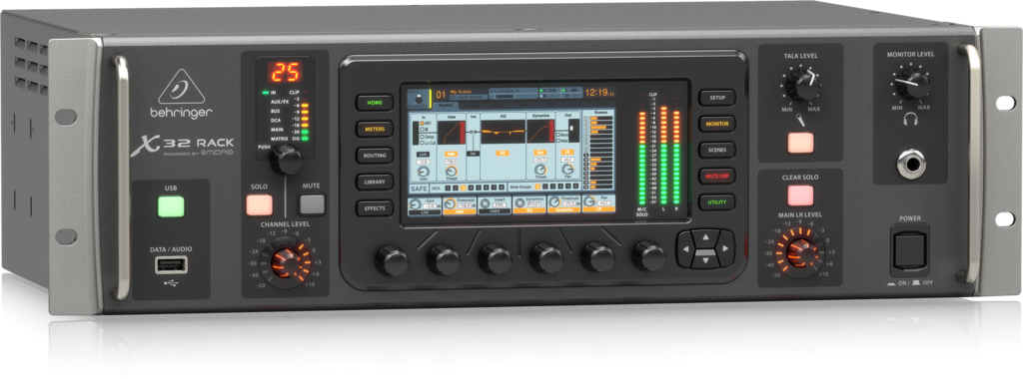
4x 230V
Video Screen (arranged by the venue in consultation with the booking office , incl projector)

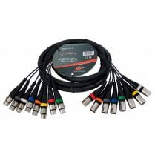

X32
Cornel

Key’s
Own In Ear
Bass AMP
Alex/ vocals

Bass Guitar
/ Vocals
3x 230V
Own In Ear

Bass Pedalb.
AXEFX3
HANS

Guitar/ vocals
3x 230V

Own In Ear

Own In Ear

Ronald

Drums

Own In Ear

5x 230V
2x 230V
HDMI Video
SD8 nr1
SD8 nr2

Key ‘s

Drumkit

RIEN
Wind Instrument / vocals

Francois

Vocal 1
/ Keys /

Voice Live2
3x 230V
Key singer

Video Projector

Appendix

Connection diagram, Backing vocals Hans are not on the picture but is necessary.

